1. Screenshorts
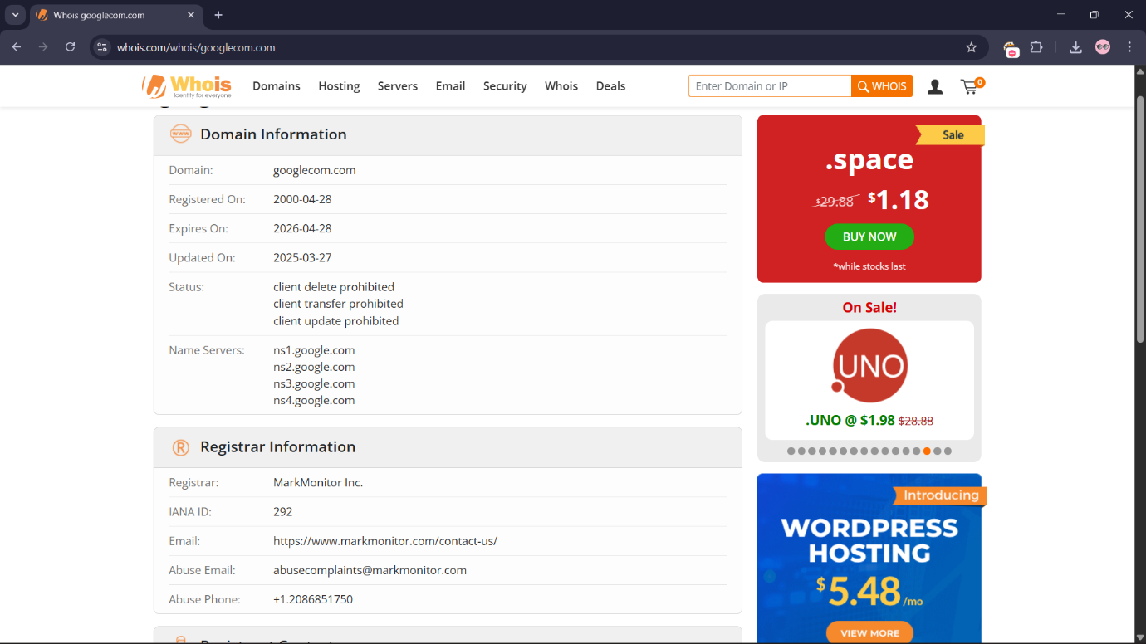
Figure 1: WHOIS Result

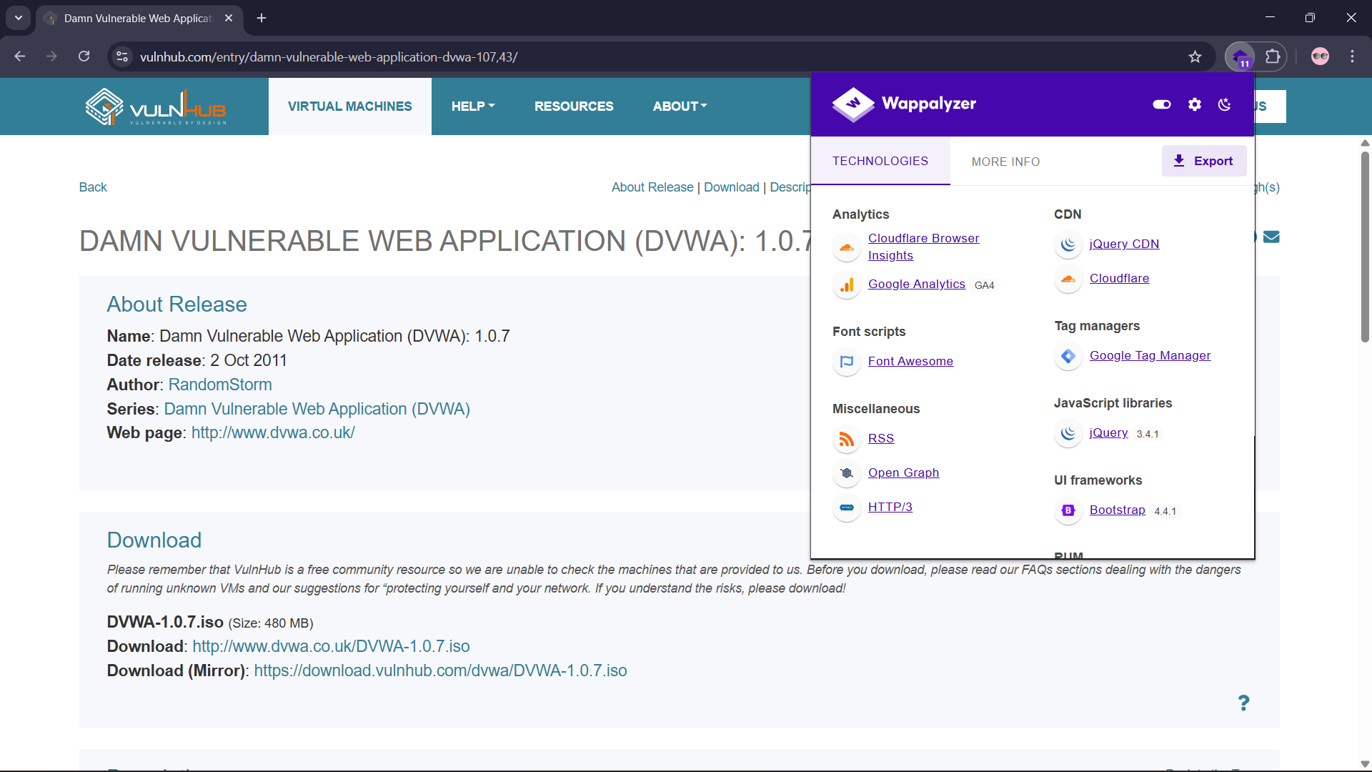
Figure 2: Wappalyzer Result

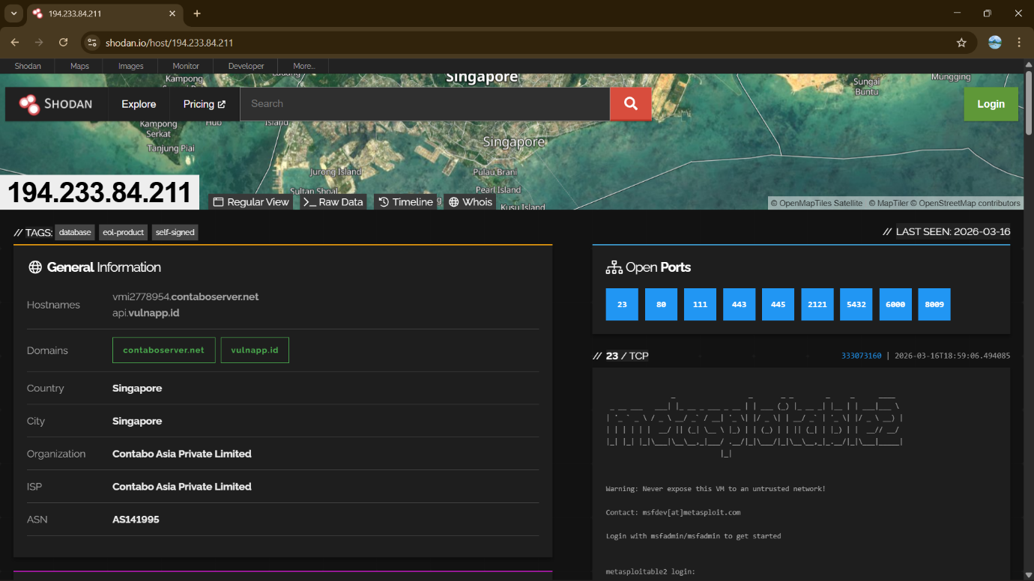
Figure 3: Shodan Result

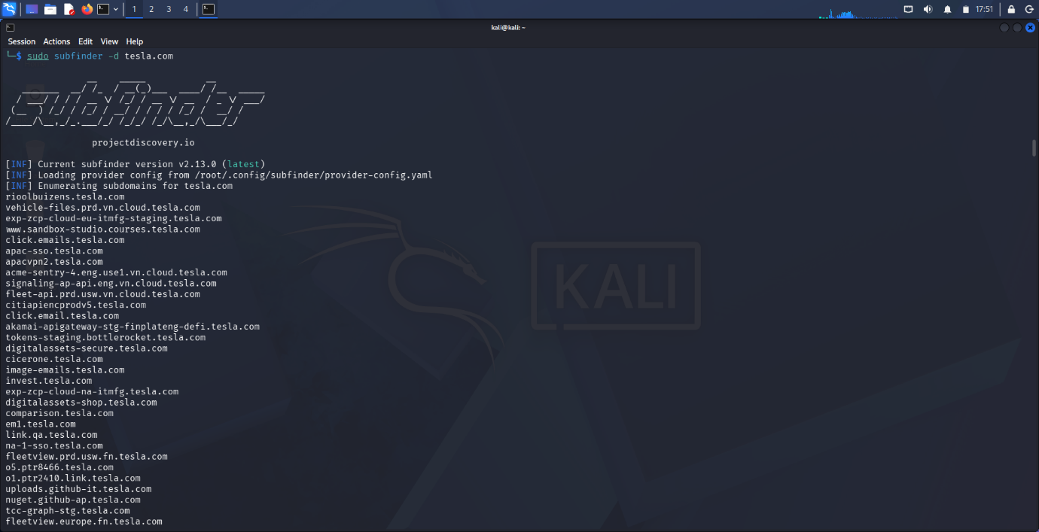
Figure 4: Subfinder Result

2. Recon Summary
The reconnaissance phase identified critical assets associated with the target domain, including multiple subdomains and exposed services such as SSH and HTTP. OSINT tools revealed the technology stack and infrastructure details, expanding the attack surface. These findings provide a strong foundation for vulnerability scanning and further penetration testing activities.

